1. **Function Constructor**

* **Syntax**



VD: viết tắt

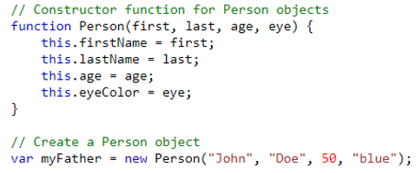

1. **Normal Function**

* **Syntax**

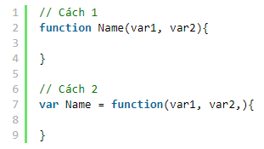

VD:

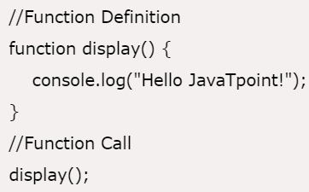

1. **Arrow Function**

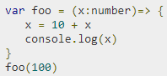

* **Reference**

<https://www.tutorialspoint.com/typescript/typescript_functions.htm>